**GANPAT UNIVERSITY**

**U. V. PATEL COLLEGE OF ENGINEERING**

**B.Tech CE/IT Semester IV**

**2CEIT404: Python Programming**

**Practical-6: Function(UDF)**

1. Write a program to perform addition of two numbers using user defined function.

INPUT:

print(21012011074)

def Add(a,b):

print("Addition of ",a,"+",b,"=",a+b)

a,b=int(input("enter the numbers: ")),int(input("enter the numbers: "))

Add(a,b)

OUTPUT:

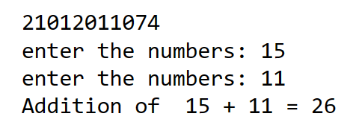

1. Write a program to display all the prime numbers between 1 to n using function.

INPUT:

print(21012011074)

def prime_no(x):

for i in range(1,x+1):

flag=0

for j in range(2,i):

if i%j==0:

flag=1

break

if flag==0:

li.append(i)

li=[]

u=int(input("Enter the upper limit: "))

prime_no(u)

print(li)

OUTPUT:

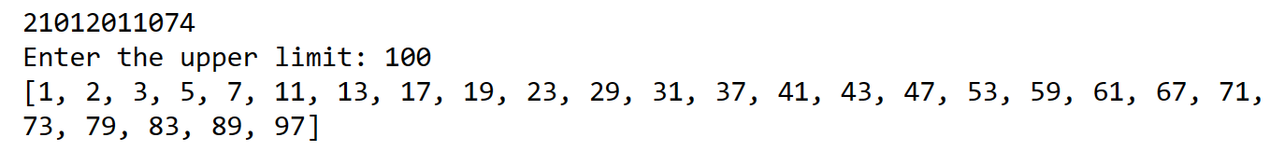

1. Write a user defined function to sort a List.

INPUT:

print(21012011074)

st=[]

n=int(input("Enter the limit of list:"))

for x in range(n):

y=int(input("Enter the number:"))

st.append(y)

# print(st)

def sort(li):

for i in range(0,len(li)-1):

for j in range(len(li)-1):

if li[j]>li[j+1]:

temp=li[j]

li[j]=li[j+1]

li[j+1]=temp

return li

b=sort(st)

print(b)

OUTPUT:

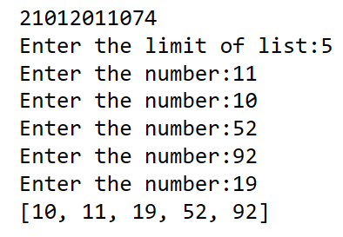

1. Write a function to find the minimum and maximum value from argument list & return both minimum & maximum in tuple form.

INPUT:

print(21012011074)

st=[1,88,191,99,91,44,65,447,100]

tup=[]

def maximum(maxx):

max_no=st[0]

for i in maxx:

if i>max_no:

max_no=i

tup.append(max_no)

def minimum(minn):

min_no=minn[0]

for i in minn:

if i<min_no:

min_no=i

tup.append(min_no)

maximum(st)

minimum(st)

tup=tuple(tup)

print(tup)

OUTSIDE:

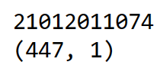

1. Write a function to add two lists of the same length term-by-term & return new list

Eg.: A=listAdd([1,2,3],[1,2,3]

print (A) Will print [2,4,6].

INPUT:

print(21012011074)

li1=[1,2,3]

li2=[4,5,6]

li3=[]

def add_list(li1,li2):

for i in range(len(li1)):

for j in range(len(li2)):

if i==j:

x=li1[i]+li2[i]

li3.append(x)

add_list(li1,li2)

print(li3)

OUTPUT:

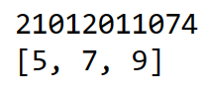

1. WAP a function called powers(n) that prints out the first 5 powers of a given number.

Eg. >>> powers(6)

The first 5 powers of 6 are: 1 6 36 216 1296

INPUT:

print(21012011074)

def power(n):

for i in range(5):

print(n**i,end=" ")

x=int(input("Enter the number"))

power(x)

OUTPUT:

